SIRM 2023 – 15th International Conference on Dynamics of Rotating Machines,

Darmstadt, Germany, 22nd – 24th February 2023

Guidelines on how to prepare a paper for the SIRM 2023 conference

**Emma One 1**, Daniel Two 2, Oliver Three 3

1 Division or Working Group, Company, Postal Code, City, Country, emma.one@company.at

2 Department or Institute, University or Institution, Postal Code, City, Country, d.two@uni.pl

3 Department or Institute, University or Institution, Postal Code, City, Country, o.three@uni.de

# Abstract

This brief document illustrates the preparation of a SIRM 2023 conference paper and also serves as a template. The authors are encouraged to prepare their papers according to this layout. The template is available on the SIRM 2023 website: [www.sirm2023.de](http://www.sirm2023.de)

However, we cannot guarantee that the template file is completely free of mistakes.

# Nomenclature

If you use many symbols in your paper it might be a good idea to make a table or list and include them in it. Otherwise, just delete this section and define symbols and acronyms in the text of the paper (where they occur for the first time).

# 1 Introduction

The layout to be used for this conference follows the common layout and typesetting rules. To help the authors, a template file is available for MS-Word and Latex. The files are prepared as if it were a conference paper. Please follow the guidelines as closely as possible. By doing so, you will save your time and the time of the conference organisation team. If your article differs considerably from the guidelines, we will have to send it back for correction.

The production of the conference proceedings will be based on PDF documents. Please submit only PDF files via the submission system <https://easychair.org/conferences/?conf=sirm2023> (see also clause 6).

# 2 Organisation

On the first page of the paper, there should be a headline indicating the conference name, date and location as shown in this template paper. The length of the title of your paper should not exceed two lines. Font size and type of the title is Times New Roman bold 14pt. Please do not use only capitals in the title. Separate title and headline as it is shown in the guidelines.

Author’s name(s) and affiliation(s) follow the title. Also include an email address. Font size and type of the author’s name is Times New Roman bold 12pt. Underline the author who is anticipated to present the paper.

Your paper should begin with an abstract. Include a list of symbols (nomenclature) if this will help to organise your paper.

The main part of the paper with numbered section headings starts with the introduction. Main section headings are typeset in Times New Roman bold 10pt, followed by as many sections and subsections as needed. The ending should feature a conclusion and a list of references. Acknowledgements (if any) may precede the references.

## 2.1 Length

The length of the abstract should not exceed 200 words (about 12 lines). The maximum length of a regular paper, including figures and tables, is to be 10 pages.

## 2.2 Layout

The width of the text body should be 16 cm and the height 24 cm. The first page of the paper starts with a headline positioned at the top of the upper border of the text body. Use Times New Roman bold 10pt for the headline. The footer is separated by 1 cm from the lower border of the text body. The print area should be in the centre of your A4 paper (horizontally and vertically). The minimum distance between the paper border and the text should be at least 1 cm. The main text has to be typeset in Times New Roman 10pt.

In any case, do not alter the template and style files you downloaded from the above-mentioned website with respect to height and width of the text body. Also, leave all settings for font size and font type unchanged.

## 2.3 Symbols and units

The use of the International System of Units (SI) is mandatory, and the use of additional (customary) units is optional.

## 2.4 Page numbering

Start page numbering in the footer on the first page with Arabic numbers in Times New Roman 10pt. Center page numbers with respect to the text body. Separate the footer by 1 cm from the lower border of the text body.

## 2.5 Paper identification number and page number

On acceptance of your paper, a paper identification number will be assigned which you may look up on the conference website. Place this number in a text field on the same line as the page numbering and align right. Use the format “Paper-ID xyz” and replace xyz by your paper number. See the example on the pages of this guide. The Paper ID should appear on each page.

# 3 Figures and tables

For the proceedings document both colour and black-and-white drawings, tables and photographs are acceptable. Please check if the coloured lines are also visible and distinguishable if printed in black and white. Please be careful not to include figures that are too large! On average a figure should not exceed 100kB to keep the size of the entire document reasonable. Frequently, the size of figures can be reduced significantly without loss of resolution when being printed or displayed.

If possible use Times New Roman font for the annotation of figures. In any case, no letters and numbers smaller than the text font size (10pt) may appear in figures and drawings! Captions should explain illustrations without a need to read the paper text. See the examples about the layout of figure captions.

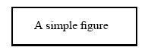

**Figure 1:** An example figure.

**Table 1:** Numerical results for *x, y, z* and *C* at different equilibrium points *Li*

|  |  |  |  |  |  |
| --- | --- | --- | --- | --- | --- |
| Equil. Points | *x* | *y* | *z* | *C* | S |
| *L1* | -2.485252241 | 0.000000000 | 0.017100631 | 8.230711648 | U |
| *L2* | 0.000000000 | 0.000000000 | 3.068883732 | 0.000000000 | S |

Use tables when numerical data are presented. Please consider that figures may illustrate the context much better than a cluster of numbers. Arrange the tables such that you take advantage of the text width, rather than making them narrow and long. You may even combine tables and figures in one line. Note that table captions are centred on top of the table, whereas captions for figures are placed below the figure(s).

# 4 Equations

All equations

 (1)

should be centred and numbered in sequence, similar to the examples given.

If you write your paper in Microsoft Word, for example, please use the Microsoft Formula Editor (usage of version 3.0 is highly recommended) for formulas and all other mathematical symbols. Note that you have to set the equation numbers manually in MS-Word. For further information see, for example, http://www.dcs.uwaterloo.ca/ec/equations/equation.html.

Several equations may be placed in one line if you separate them clearly:

. (2)

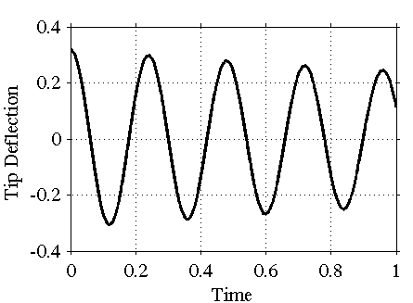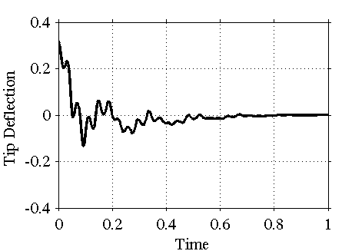

**Figure 2:** Vibration signal at the tip of a cantilever beam. (Left) free oscillations without parametric excitation, (right) with optimal harmonic axial force excitation.

Symbols used in the text body should be of the same font size and style as used in equations. Here we use  and *j* which denote the j-th natural frequency of the system. Formulas embedded in the text like  should be avoided, unless they are very short and do not need to be numbered.

Refer to equations by using the numbers assigned to them. Equation (1) is the first equation. Please note that in MS-Word it can be dangerous to set formulas within the main text. In some cases, MS-Word will not count the equation numbers correctly!

# 5 Bibliography

List all bibliographical references at the end of the paper in the manner shown below (the list should be prepared in alphabetic order with respect to the last name of the first author). Include the year of publication within parentheses just after the last author. Note the different style of references and use them as shown below, when you list books, journal papers, proceedings papers or monographs. Refer to references in the text as follows: Childs discusses this case in [2]. Other authors have also carried out experimental studies, see [4], [5] and [6].

# 6 Paper submission

Your **draft paper** should be submitted **as a PDF-file** via submission system (<https://easychair.org/conferences/?conf=sirm2023>) no later than by **October 12th, 2022**. Your **final paper** should be submitted also via the submission system no later than by **December 1st, 2022**. Faxed submissions will not be accepted! The size of the files may not exceed **15 MB**.

# 7 Conclusion

A carefully prepared manuscript that follows the layout rules as explained in this document will make a better presentation of your work and spare us unnecessary effort in pestering you to get it right. Good luck!

# Acknowledgement

Acknowledgement text

# References

|  |  |
| --- | --- |
| [1] | Abadi, A. (2003): *Nonlinear Dynamics of Self-excitation in Autoparametric Systems.* Dissertation, Utrecht University, Utrecht. |
| [2] | Childs, D. (1993): *Turbomachinery Rotordynamics.* Wiley-Intersciences, New York. |
| [3] | Kicinski, J., Zywica, G. (2012): The numerical analysis of the steam microturbine rotor supported on foil bearings. *Advances in Vibration Engineering*, 11(2), pp. 113-119. |
| [4] | Sato, R. (1989): EMC – The past, present and future. In *Proc. Int. Symp. on Electromagn. Compat.*. Nagoya, Japan, Sept. 8-10, pp. 1–9. |
| [5] | Tondl, A. (1965): *Some Problems of Rotordynamics*. Chapman and Hall, London. |
| [6] | Wang, J., Sasabe, K. und Fujiwara, O. (2002): A simple method for predicting common-mode radiation from a cable attached to a conducting enclosure. *IEICE Trans. Commun.*, E85-B(7), pp. 1360–1367. |